CS 330 – Scheme
A Breadth First Search Example

The farmer, wolf, goat, and cabbage problem (FWGC):

A farmer with his wolf, goat, and cabbage come to the west side of a river they wish to cross. There is a boat at the river’s edge, but, of course, only the farmer can row it. The boat can carry two things (including the rower) at a time. If the Wolf is ever left alone with the goat, with or without the cabbage, the wolf will eat the goat. Similarly, if the goat is left alone with the cabbage, the goat will eat the cabbage. Device a sequence of actions such that all four characters arrive safely on the east side of the river.

http://watson.latech.edu/WatsonRebootTest/ch14s3p1.html

4 possible actions (or operations):

A solution illustration:
farmer-take-self (F)
farmer-take-wolf (FW)
farmer-take-goat (FG)
farmer-take-cabbage (FC).

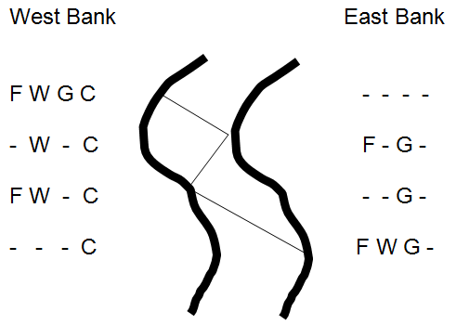
State Space: all the states reachable from start state via a sequence of applications of the 4 operations

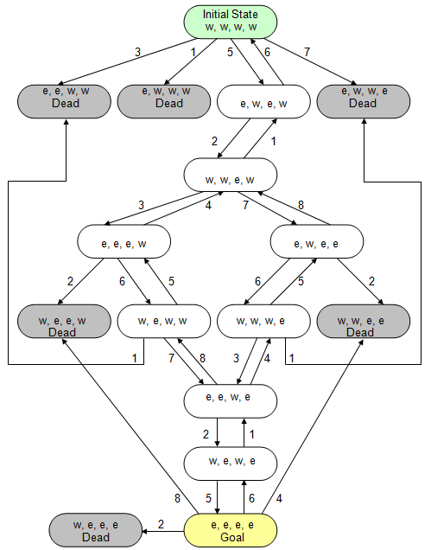

BFS with scheme

Data Structure: List

State: A list describing the location of each of the 4 main characters (F W G C)
Ex., at the beginning (e e e e)

Dynamic Breadth First Search (DBFS) Algorithm

BFS to find the shortest path from the start/initial state (i.e., root of the search tree) to a goal state. Note that
- The search tree is most often generated dynamically such as in FWGC programs.
- There could be more than one goal state, or solution paths. However, the search usually stops when a goal state is found.

Data Structure – A queue Q (First In First Out)

C++: queue<state*> Q; // a pointer to a struct named state
// You could implement your own queue but using the queue class from STL is much easier

Struct state
{
String location; // of FWGC, a string of 4 characters.
…
}

Scheme: path-list, i.e., a list of paths

State = a list of 4 symbols (i.e., locations), Ex., (e w e w)
Path = a list of states, ex., ( (e w e w) (w w w w) )
;; init and successor from Farmer-takes-goat

Path-List = a list of paths, ex., ( (e w e w) (w w w w) ( ….) …. )

path1 path2
BFS in General:
Add root (start state) to Q
while (Q is not empty && front of Q does not match goal)
{
remove the first element from Q, and store it in a variable named cur-node
generate all child nodes of cur-node and push the new ones into the Q
;; we only add those that are new and (not unsafe)

}
If Q is empty
fail
else
return get-solution-path(cur)
;; find a solution path from cur to start, how do we do this in C++?
;; we add a pointer field from each node to its parent: note *parent;

Initial content of Queue: (w w w w), below is an example partial search tree

(w w w w)
F FC
FW FG
(e w w w) (UnSafe) (e e w w) (US) (e w e w) (e w w e) (US)

F FW FG FW

(w w e w) fail (w w w w) (repeat) ‘() // op not applicable

Scheme implementation

How do we model the transitions?

Define functions, or operators, one for each 4 operation.
Ex.,
(farmer-take-cabbage ‘(w w e w))
→ (e w e e) ;; example call and result

(define farmer-take-cabbage
(lambda (state)
(cond ((= (car state) (cadddr state)
(list (opposite (car state)) (cadr state) (caddr state) (opposite (cadddr state)))
(else state))) ;; state has no change if the op is not applicable

Each problem state can be represented by a list of four elements (f w g c), where each element denotes the location of the farmer, wolf, goat, and cabbage, respectively. The value of each element is either e (east side) or w (west side). Thus, the initial state could be represented by (e, e, e, e), and the goal state could be represented by the list (w w w w).

We could write a main function fwgc (i.e., bfs), which accepts two arguments indicating the initial state and the goal state. It returns the list of states from initial to the goal if a solution is found, ‘() otherwise. For example, (fwgc ‘(e e e e) ‘(w w w w)) returns
((e e e e) (w e w e) (e e w e) (w w w e) (e w e e) (w w e w) (e w e w) (w w w w))

At any point, farmer can take one of 4 actions:
- farmer-take-self
- farmer-take-wolf
- farmer-take-goat
- farmer-take-cabbage

fwgc: a list named path-list → a list of paths

Initial content of Queue: ( (w w w w) ), below is an example partial search tree using path

( ( (w w w w) ) )
F FC
FW FG
(e w w w) (US) (e e w w) (US) ( (w e w e)(e e e e) ) (e w w e) (US)

F FW FG FC

( ( (e e w e) (w e w e) (e e e e) ) ) fail (e e e e) (repeat)

Implementation

Fwgc in Scheme:
- Each node in the search tree represents a state. For example, (e e e e) represents the state where everything is on the east side.
- Each element in path-list is a path from a current node to the start node (i.e. root), for example, ( (e e w e)(w e w e) (e e e e) )
^ ^
current start
- path-list ( ((e e w e)(w e w e) (e e e e)) ….)

- (caar path-list) returns the current state of the first path in the path-list queue.
- The op-list is a list of procedure name (i.e., the operators) which are used to generate child nodes

The fwgc BFS using path and path-list

Add a path of only the stat state to path-list
Ie., path-list = ( ( (w w w w) ) )

while (path-list is not null AND (caar path-list) is not a goal state)
{
extend (car path-list) // i.e., extend the 1st path in the path-list
}

if (path-list is empty)
return ‘() ;; fail
else
return (reverse (car path-list))
;; car path-list is a solution path from goal to start

The Extend function:

ops ⬅ op-list
cur-node ⬅ (caar path-list) ;; path-list is locally called lst
while (ops is not empty)
{
new ⬅ ( (eval (car ops)) cur-node) ;; apply the first operator in ops on
;; to create a child node, stored in new
if (new is not already in path-list) ;; i.e., has not been generated before
add (cons new (car path-list)) to the end of path-list
^ this is a new path with new added to the beginning of the first path
ops ⬅ (cdr ops)
}
remove the first path (i.e., car) from path-list ;; it has been extended

return path-list

(cons new (car path-list)) is a new path equal to the first path of path-list + a new state added at its front, For example,

path-list :
( ((w w w e) (e e w e) (w e w e) (e e e e)) ((w e w w) (e e w e) (w e w e) (e e e e)) …)
^ ^ ^
first path second path other paths

(car path-list): ((w w w e) (e e w e) (w e w e) (e e e e))

new: (e w e e) ;; obtained by applying Farmer-take-Goat to (caar node-list)

(cons new (car path-list)) : ((e w e e) (w w w e) (e e w e) (w e w e) (e e e e))

path-list after this update:
(((w e w w) (e e w e) (w e w e) (e e e e)) … ((e w e e) (w w w e) (e e w e) (w e w e) (e e e e)))
^ ^ ^
first path other paths new path

Note that:
To change the current state to a new state (i.e., extend the current path). Each action can be represented by a scheme procedure that takes a state argument and return a new state. For example,
(farmer-take-wolf ‘(e e e w)) ➔ (w w e w)
^ ^
|| ||
current state new state
(farmer-take-cabbage ‘(e e e w)) ➔(e e e w)
(Why is there no change here? Because the operation is not applicable, farmer and cabbage are not at the same side)

Before a new path contain a new state is added to the end of the search queue, it must satisfy the following two conditions:

- the new state has not been generated previously, i.e., it is not in any of the paths of the queue.
- the new state is not unsafe. A state is unsafe if either the goat is alone with the cabbage or the wolf is alone with the goat. For example, (e e w w) is an unsafe state since the goat is alone with the cabbage on the west side of the river.

Search space of 8puzzle
